|  |  |  |  |
| --- | --- | --- | --- |
| **Classics &** **Cool Concoctions** **Café Barbados**  A blend of Kahula, Bailey’s and Grand Marnier, in Coffee topped with whipped cream and cherry. 9.50    **Patron Perfect Margarita**  *Patron Reposado Tequila, Patron Citronge Liqeur and lime juice, served on the rocks. 12.00*  **Gregory’s Watermelon Margarita**  *Patron Silver Tequila, DeKuyper Watermelon Pucker, Triple Sec and Sweet & Sour Mix served on the Rocks. 12.00*  **Blue Cosmopolitan**  *Absolut Citron Vodka, Dekuyper Blue Curacao, a splash of grapefruit and cranberry juice. 11.00*  **Rum Runner**  *It’s run for the islands with this refreshing*  *Blend of blackberries, Cherries, Bananas,*  *Lime Juice and Dark Rum. 11.00*  ***Fireball shots $3.00***  ***Jaegermeister shots $4.00*** |  |  | Image of the word 'menu' drawn in calligraphy **Black-N-Bleu Burger**  Blackened 10oz. Prime cut beef patty topped with caramelized onions, crumbled bleu cheese and crispy potato straw.  16.00    **Pancetta Egg Burger**  Char-grilled 10oz. Prime Cut beef patty topped with Applewood smoked cheddar, pancetta and a fried egg. Choice of side item.  16.00  **Hot Chicken Sandwich** (Blackened)  9.00  **Buffalo Wings Chicken Fingers**  (aprox.10) 9.00 8.00  **Chicken Caesar Salad**  14.00  **Philly Cheesesteak Sandwich**  12.00  **Just Fries**  4.00  **Gregory’s Garlic Shrimp**  Premium Shrimp sautéed in a spicy fresh garlic, jerk and Cajun sauce.  12.00 |

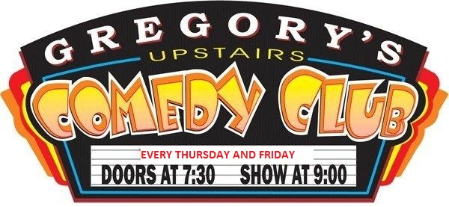

**Book Your Next Event with us we have**

**2 Banquet Rooms Available**

**Semi-Private**

**2 - 30 guests**

**Or**

**Private Upstairs**

**20 – 100 guests**

**Email to check availability and menu information:**

**info@gregorysonthebeach.com**

Late Night Menu

Gregory’s Comedy Club

900 N. Atlantic Avenue Cocoa Beach, FL 32931

321-799-2557

[www.GregorysComedyClub.com](http://www.GregorysComedyClub.com)

01/2016